Lab no 07

STL Container Adaptors:

Stack & Queue
Task 1: Comparing Stacks & Queues [5+5+5=15]
Part A: Compare Two Stacks [05]
Two stacks of the same type are the same if they have the same number of elements and their elements at the corresponding positions are the same.
Write and template based function isStacksSame, which takes two stacks as input, compares them and return, true if both stack are equal, false otherwise.
Program:
#include <iostream>
#include <stack>
using namespace std;

template <typename T>
bool isStacksSame(stack<T> s1, stack<T> s2) {
if (s1.size() != s2.size())
return false;
while (!s1.empty()) {
if (s1.top() != s2.top())
return false;
s1.pop();
s2.pop();
}
return true;
}
int main() {
stack<int> s1, s2;
s1.push(10);
s1.push(20);
s1.push(30);
s2.push(10);
s2.push(20);
s2.push(30);
if (isStacksSame(s1,s2))
cout << "Stack are same of given values" << endl;
else
cout << "Stacks are not sme" << endl;

return 0;
}

Output:
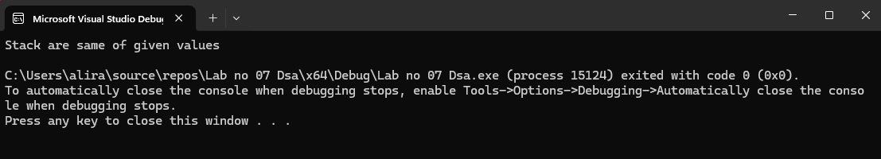
Part B: Compare Two Queues [05]
Two queues of the same type are the same if they have the same number of elements and their elements at the corresponding positions are the same.
Write and template based function isQueuesSame, which takes two queues as input, compares them and return, true if both queues are equal, false otherwise.
Program:
#include <iostream>
#include <queue>
using namespace std;

template <typename T>
bool isQueuesSame(queue<T> q1, queue<T> q2) {
if (q1.size() != q2.size())
return false;
while (!q1.empty()) {
if (q1.front() != q2.front())
return false;
q1.pop();
q2.pop();
}

return true;
}

int main() {
queue<int> q1, q2;

q1.push(10);
q1.push(20);
q1.push(30);

q2.push(10);
q2.push(20);
q2.push(30);
if (isQueuesSame(q1, q2))
cout << "Queues are same";
else
cout << "Queues are not same";
return 0;
}
Output:
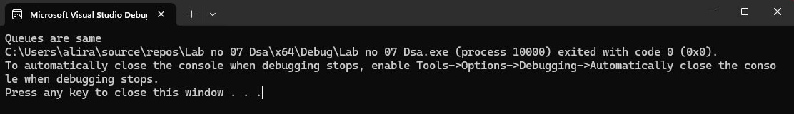
Part C [05]
Create two stacks and queues in main function and demonstrate working of both above created functions. You can populate stacks and queues with some random values.
Program:
#include <iostream>
#include <stack>
#include <queue>
using namespace std;
template <typename T>
bool isStacksSame(stack<T> s1, stack<T> s2) {
if (s1.size() != s2.size())
return false;

while (!s1.empty()) {
if (s1.top() != s2.top())
return false;

s1.pop();
s2.pop();
}
return true;
}
template <typename T>
bool isQueuesSame(queue<T> q1, queue<T> q2) {
if (q1.size() != q2.size())
return false;

while (!q1.empty()) {
if (q1.front() != q2.front())
return false;

q1.pop();
q2.pop();
}
return true;
}

int main() {
stack<int> s1, s2;

s1.push(5);
s1.push(10);
s1.push(15);

s2.push(5);
s2.push(10);
s2.push(15);
queue<int> q1, q2;

q1.push(1);
q1.push(2);
q1.push(3);

q2.push(1);
q2.push(2);
q2.push(4)

if (isStacksSame(s1, s2))
cout << "Stacks are same\n";
else
cout << "Stacks are not same\n";
if (isQueuesSame(q1, q2))
cout << "Queues are same\n";
else
cout << "Queues are not same\n";

return 0;
}
Output:
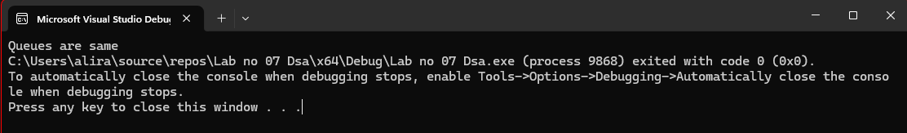
Task 2: Reverse Stack & Queue [5+5+5=15]
Part A [05]
Write a function template, reverseStack, which takes a stack object as input parameter and uses a queue object to reverse the elements of the stack.
Program:
#include <iostream>
#include <stack>
#include <queue>
using namespace std;

template <typename T>
void reverseStack(stack<T>& s) {
queue<T> q;
while (!s.empty()) {
q.push(s.top());
s.pop();
}

while (!q.empty()) {
s.push(q.front());
q.pop();
}
}

template <typename T>
void printStack(stack<T> s) {
while (!s.empty()) {
cout << s.top() << " ";
s.pop();
}
cout << endl;
}

int main() {
stack<int> s;

s.push(1);
s.push(2);
s.push(3);
s.push(4);

cout << "Original Stack of element: ";
printStack(s);

reverseStack(s);

cout << "Reversed Stack of the eleemnt: ";
printStack(s);

return 0;
}
Output:
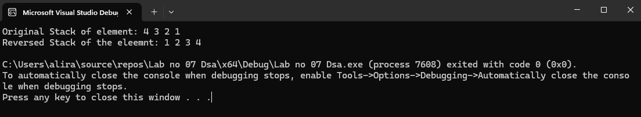
Part B [05]
Write a function template, reverseQueue, which takes a queue object as input parameter and uses a stack object to reverse the elements of the queue.
Program:
#include <iostream>
#include <queue>
#include <stack>
using namespace std;

template <typename T>
void reverseQueue(queue<T>& q) {
stack<T> s;

while (!q.empty()) {
s.push(q.front());
q.pop();
}

while (!s.empty()) {
q.push(s.top());
s.pop();
}
}
Part C [05]
Create a stack and queue in main function and demonstrate working of both above created functions. You can populate stack and queue with some random values.
Program:
#include <iostream>
#include <queue>
#include <stack>
using namespace std;

template <typename T>
void reverseQueue(queue<T>& q) {
stack<T> s;

while (!q.empty()) {
s.push(q.front());
q.pop();
}

while (!s.empty()) {
q.push(s.top());
s.pop();
}
}

int main() {
queue<int> q;
q.push(5);
q.push(10);
q.push(15);
q.push(20);
q.push(25);
cout << "Original Queue: ";
queue<int> temp = q;
while (!temp.empty()) {
cout << temp.front() << " ";
temp.pop();
}
cout << endl;
reverseQueue(q);
cout << "Reversed Queue: ";
while (!q.empty()) {
cout << q.front() << " ";
q.pop();
}
cout << endl;

return 0;
}
Output:
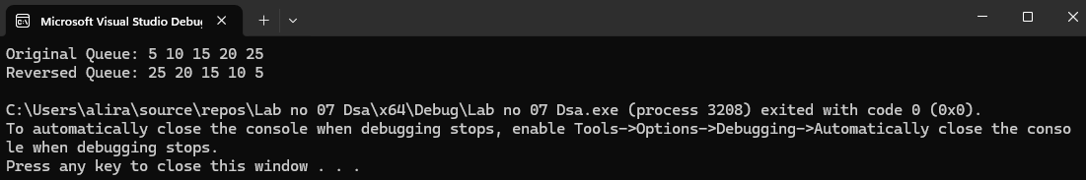
Task 3: Palindrome [10+10=20]
A palindrome is a word, phrase, number, or other sequence of symbols or elements, whose meaning may be interpreted the same way in either forward or reverse direction.
Famous examples include “mom”, “dad”, “123454321” “Amore, Roma”, “A man, a plan, a canal: Panama” and “No ‘x’ in ‘Nixon’ ”, etc.
Part A [10]
Let us try to use stack to evaluate whether a given string is palindrome or not. Write a function isPalindrome, which takes a string as input and returns a Boolean value describing that given string was palindrome or not. (Note: Stack must be used in this algorithm.)
Program:
#include <iostream>
#include <stack>
using namespace std;

bool isPalindrome(string str) {
stack<char> s;

for (int i = 0; i < str.length(); i++) {
s.push(str[i]);
}

for (int i = 0; i < str.length(); i++) {
if (str[i] != s.top()) {
return false;
}
s.pop();
}

return true;
}

int main() {
string word;

cout << "Enter a word: ";
cin >> word;

if (isPalindrome(word)) {
cout << "It is a Palindrome." << endl;
}
else {
cout << "It is NOT a Palindrome." << endl;
}

return 0;
}
Output:
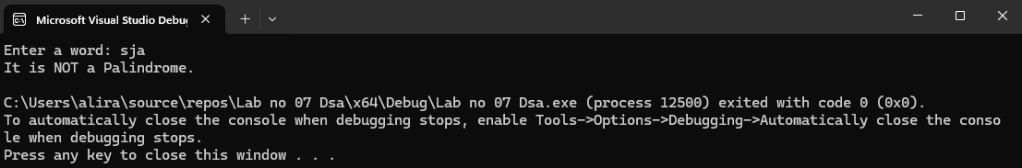
Part B [10]
You are given a text file ‘lab7task3.txt’, which contains different sentences on each line. Read that text file in main function and using above created (i.e. isPalindrome) function to check whether each sentence is palindrome or not. You have to write output on another text file.
Program:
#include <iostream>
#include <fstream>
#include <stack>
using namespace std;
bool isPalindrome(string str) {
stack<char> s;

for (int i = 0; i < str.length(); i++) {
s.push(str[i]);
}
for (int i = 0; i < str.length(); i++) {
if (str[i] != s.top()) {
return false;
}
s.pop();
}

return true;
}

int main() {
ifstream inFile("lab7task3.txt");
ofstream outFile("output.txt");

string line;
while (getline(inFile, line)) {

if (isPalindrome(line)) {
outFile << line << " -> Palindrome\n";
}
else {
outFile << line << " -> Not Palindrome\n";
}
}

inFile.close();
outFile.close();

cout << "Done! Check output.txt file." << endl;

return 0;
}
Output:
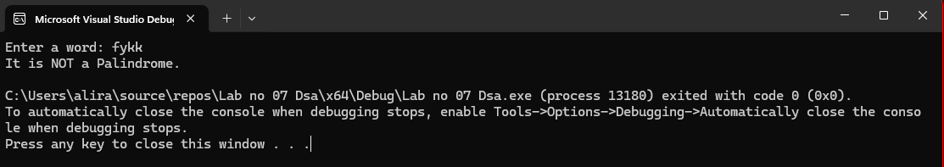
Task 4: Postfix to Infix Conversion [15]
One of the applications of stack is in the evaluation of arithmetic expressions. To evaluate any arithmetic expression we need to convert the infix expression to postfix. Then we evaluate the postfix expression using a stack. Brows Internet to explore what is postfix expression and how it is different from infix expression.
Algorithm for infix to postfix conversion, assuming that there are single digits numbers in infix expression:
Write code for the above algorithm and name that function infix2postfix. This function takes a string containing infix expression and a postfix string. Also demonstrate working of infix2postfix function.
Program:
#include <iostream>
#include <stack>
using namespace std;

void infix2postfix(string infix) {
stack<char> s;
string postfix = "";

for (int i = 0; i < infix.length(); i++) {
char ch = infix[i];

if (ch >= '0' && ch <= '9') {
postfix += ch;
}

else if (ch == '(') {
s.push(ch);
}

else if (ch == ')') {
while (!s.empty() && s.top() != '(') {
postfix += s.top();
s.pop();
}
s.pop();
}

else {
s.push(ch);
}
}
while (!s.empty()) {
postfix += s.top();
s.pop();
}

cout << "Postfix: " << postfix << endl;
}

int main() {
string infix;

cout << "Enter infix: ";
cin >> infix;

infix2postfix(infix);

return 0;
}
